UNDERWATER HOCKEY
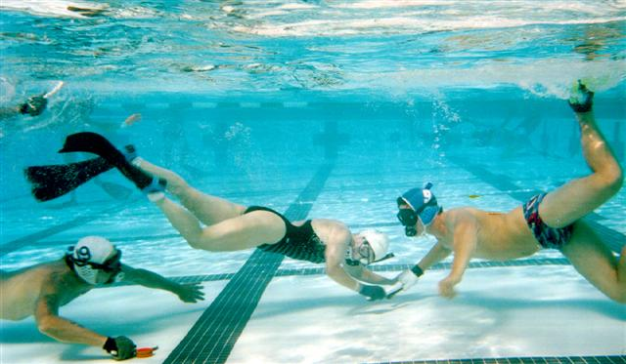
PLAYERS WANTED!

Underwater hockey is played by teams of 6 players on the bottom of a swimming pool. Each player is equipped with mask, snorkel, fins and protective glove. Black and white sticks identify teams. The object is to push, pass, and shoot a coated lead puck along the bottom of the pool all while holding one’s breath. Underwater Hockey is a NON-Contact sport. Rules ensure players have a high level of enjoyment by emphasizing finesse and teamwork.

Underwater hockey is a great cardiovascular workout and lots of FUN! It is a great way to get in shape and have fun at the same time. Play is coed and any age above 16 can play. Equipment, other than mask, fins and snorkels, is cheap to make or buy.

For more information about this fun sport:

Contact Kevin Barnes 817-832-0761
kevin_barnes@bigfoot.com

